NeXT OEE, production change

1) open the list of workorders
Press on the “OP” button to open the list. That list is sorted by release date in ascending order.

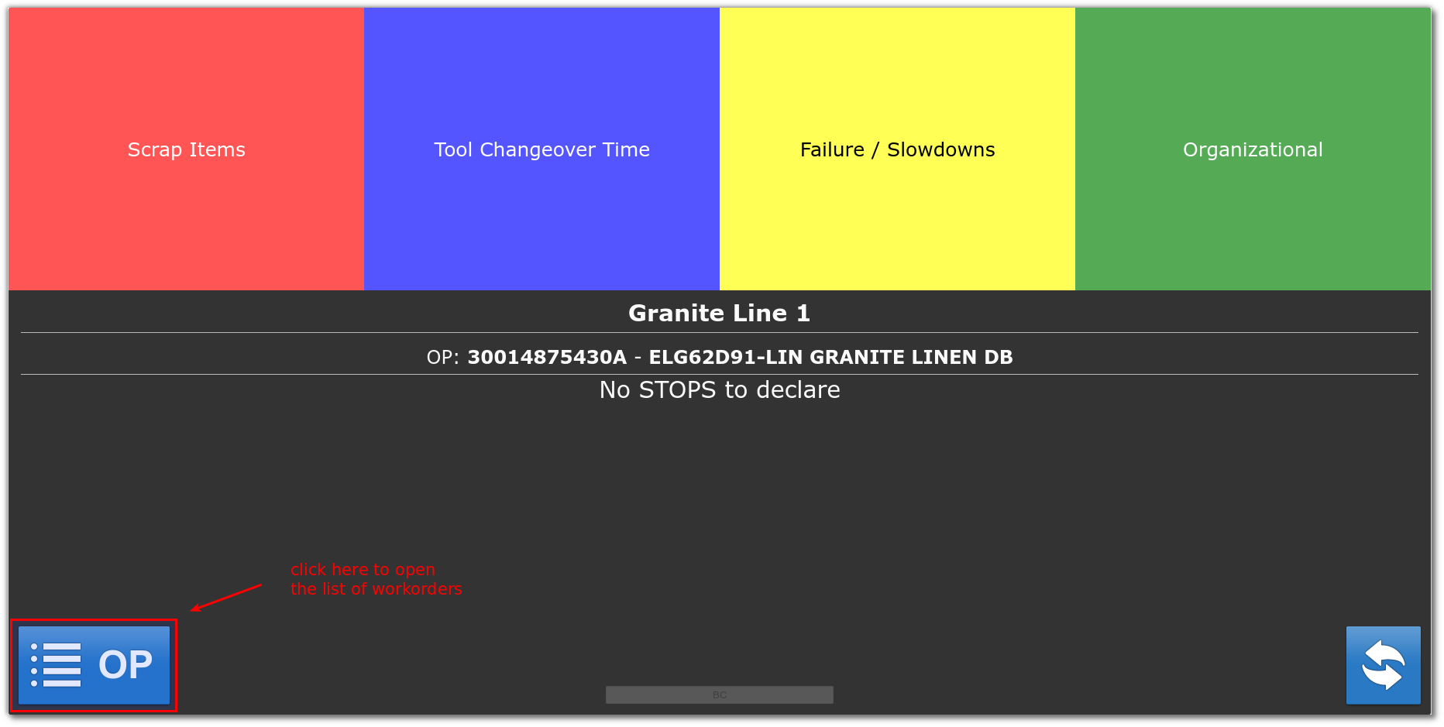

2) choose the workorder from the list
Use the buttons at the bottom to navigate. Press the “Play” button on the desired workorder to start a new production. A confirmation message will be shown.

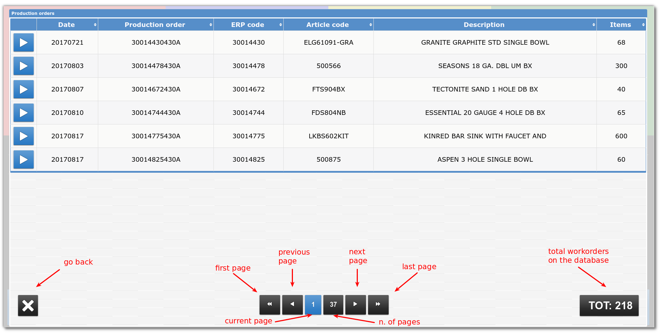
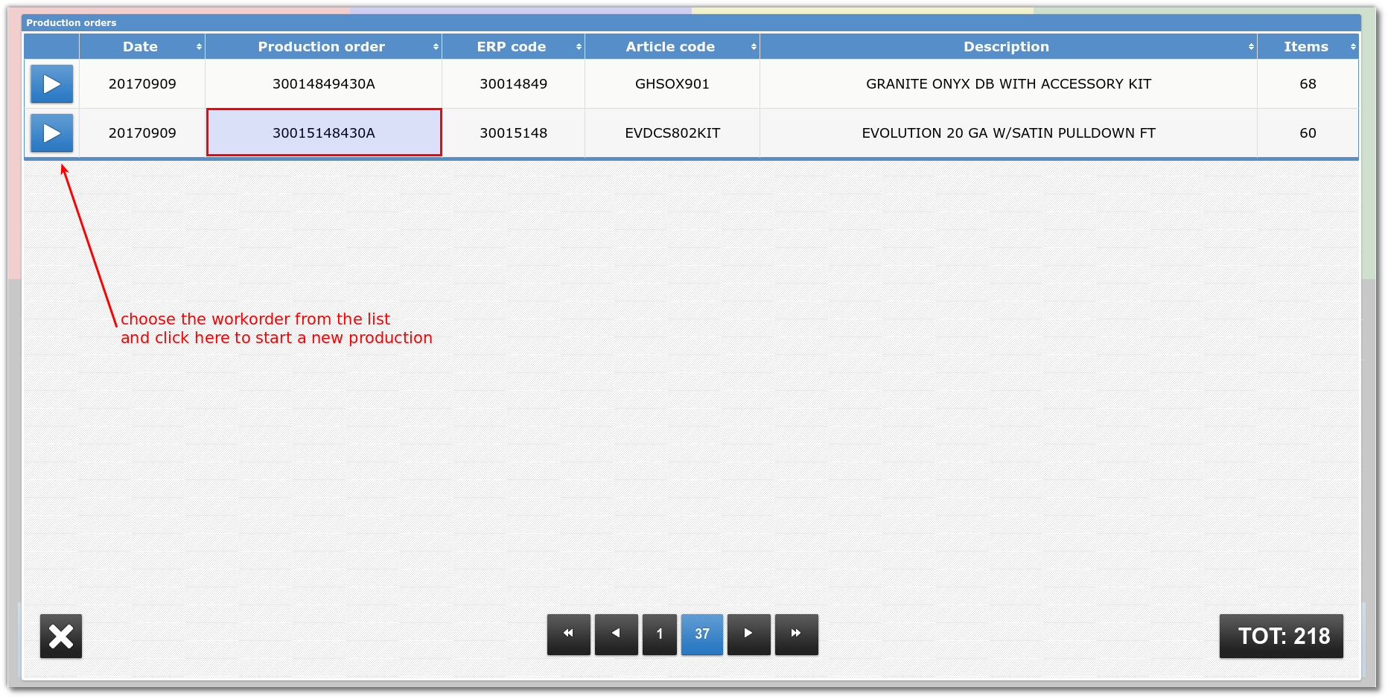

3) verify information on the touch panel
The new production will be configured and the information about the selected work order will be shown on the touch panel.

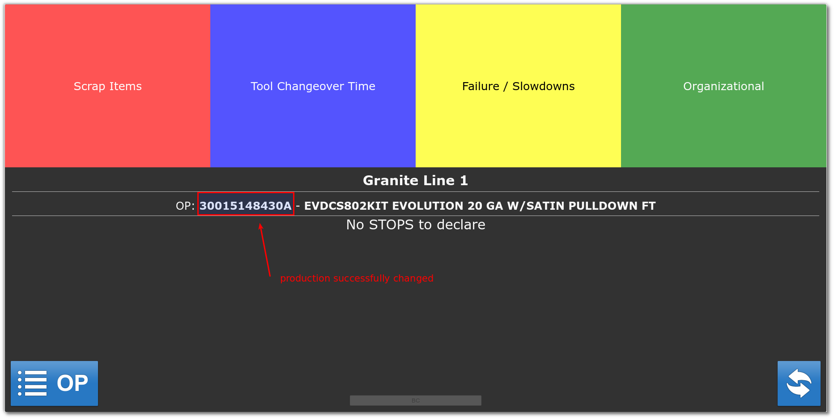

DONE

