Fabricated Industry 4.0

Revisions 2
Introduction 3
Department production general characteristics 4
Fabricated line overview 5
General flux of information 6
S/N univocity 7
Laser 9
Input 10
Output 11
Data 12
Piegatura 14
Input 16
Output 17
Data 18
Saldatura 20
Input 21
Output 21
Data 22
Personalizzazione 24
Input 26
Output 27
Data 27
New item 29
Traceability 30
Articles 30
Pallet 31
AGV - API Rest Server SAP -> NIS 33
Improve 4.0 Mobile 37

Revisions

Version | Owner | Date | Status | Notes
0.1 | Irene Orienti | Apr 18th | Approved | first draft
0.2 | Mirco Zingaretti | Jul 14th | Draft | Export Google DOC
 |  |  | Draft
 |  |  | Draft

Introduction

Aim of this document is to describe the Franke Fabricated Industry 4.0 Production lines related to the Peschiera Plant.

These new productions lines are online and productive following Industry4.0 models and standards since April 2023.

Two main departments are involved in the process: Cella Laser and Cella Piegatura.
Data are handled throught barCode readers, Touch screens, the Improve 4.0 web applications and Improve 4.0 mobile application.

Department production general characteristics

Impianto TAGLIO COIL
X shape

LASER
(Industry 4.0)
optional component

PILETTA
folded

PIEGATURA
(Industry 4.0)

SALDATURA
(Industry 4.0)

PERSONALIZZAZIONE
(Industry 4.0)

OPERAZIONI MANUALI

LAVAGGIO

IMBALLO

Fabricated line overview

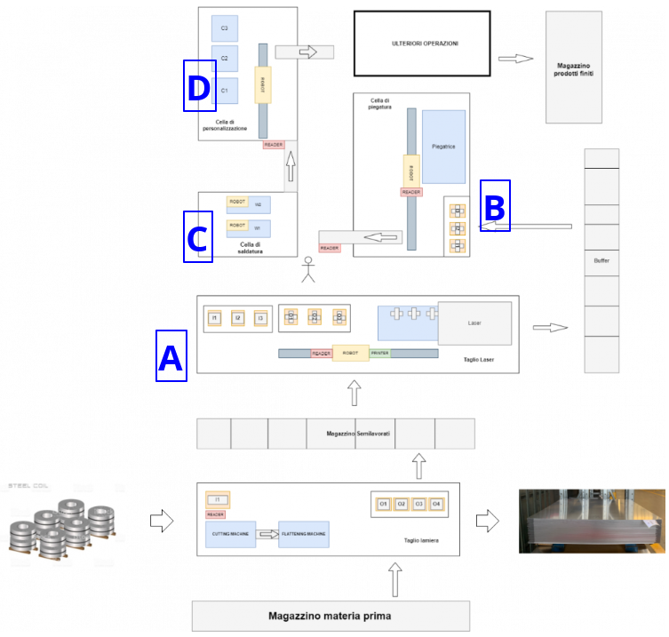

Industry 4.0
A : Laser
B : Piegatura
C : Saldatura
D : Personalizzazione

General flux of information

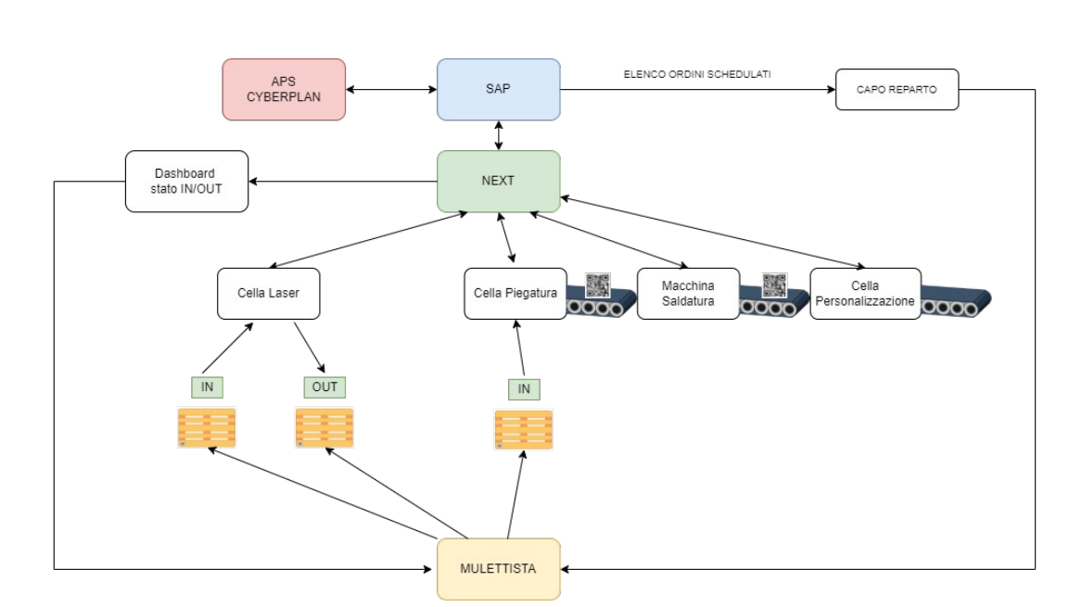
Data exchange between NEXT and actors of the lines it is happening throught the standard protocol OPC UA.

S/N univocity

Each and every piece has been identified throught the code

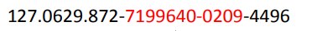

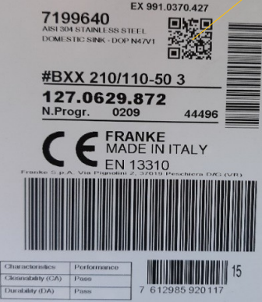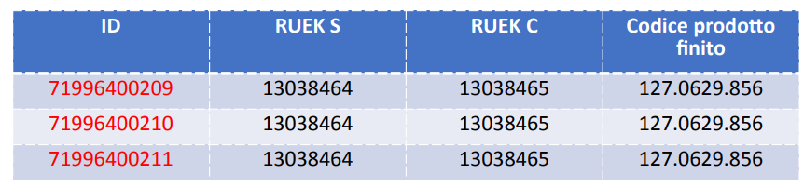

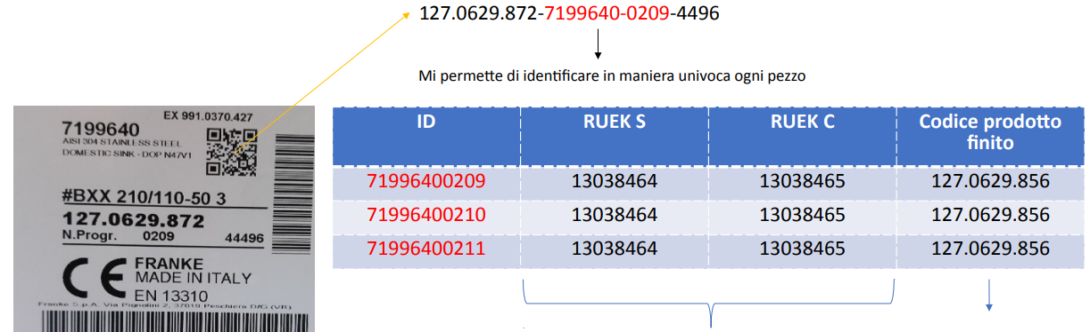

RUEK S and RUEK C are codes that are used by Next to get the SAP item from the system, within the necessary data for the OEE calculation
‘Codice prodotto finito’ it is a code that is inserted manually from the operator. It is not available through RUEKs because it is related the finished product, that is port of a different flux of information

Laser

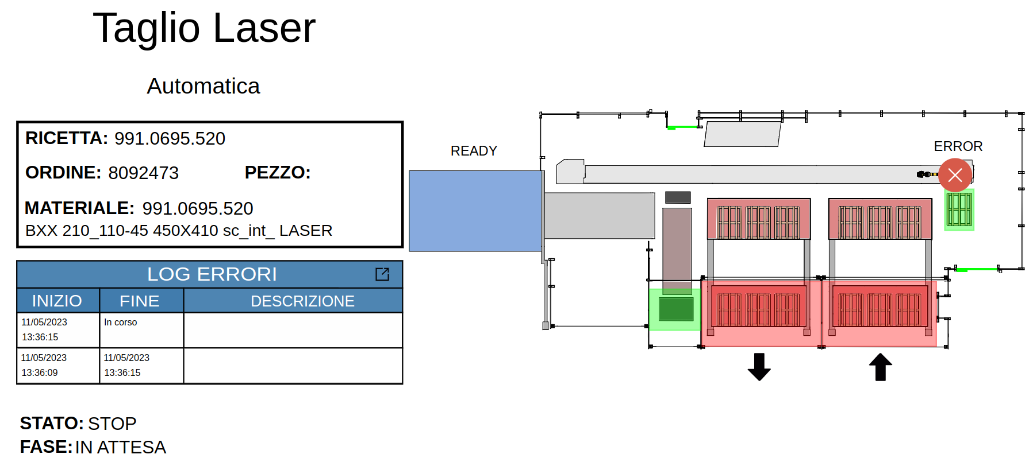

For each pallet the operator assigns the RUECK sequence to the pallet QRCode
During the label printing operation, for each piece, all the pallet informations are matched to the piece QR code
Informations RUEK P, RUEK S, RUECK C, Codice Formato, Numero Ordine Formato, Numero Pezzi, that are currently associated to the input pallet, are not matched with the output pallet too.

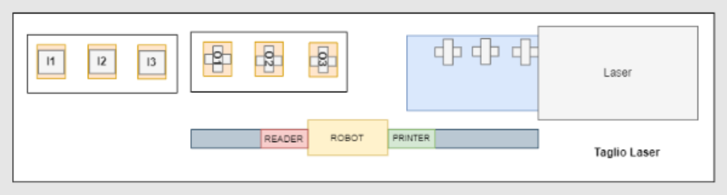

Input
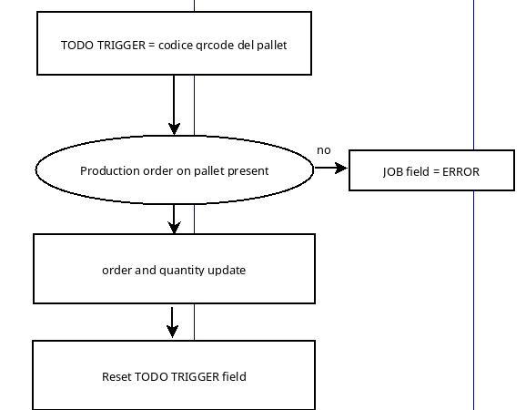

Output
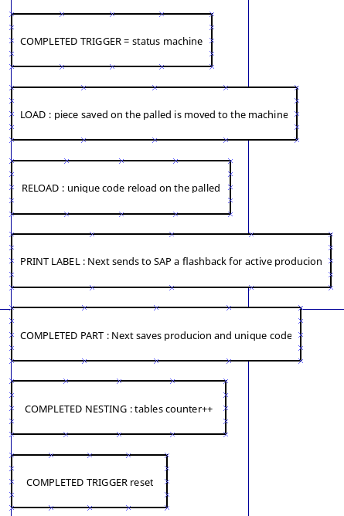

Data
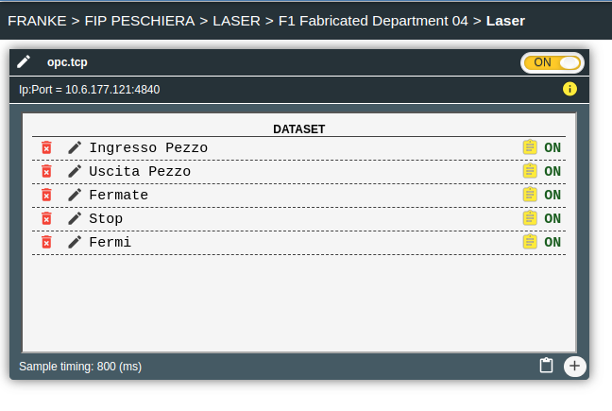

Input variables
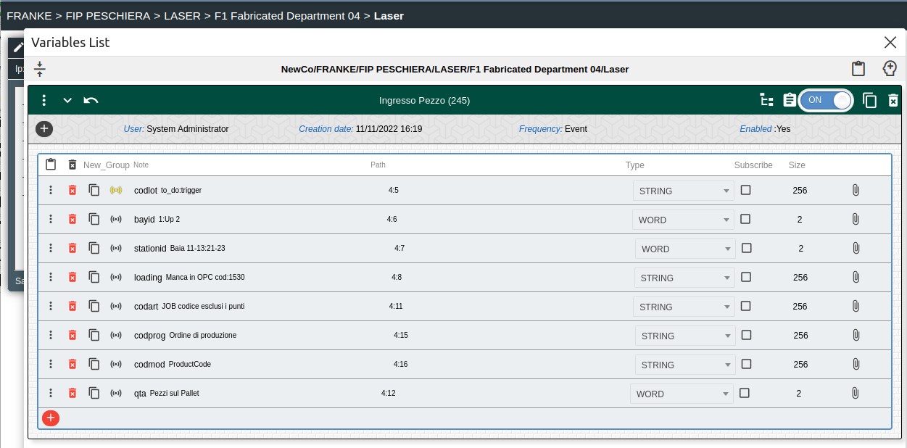

output variables
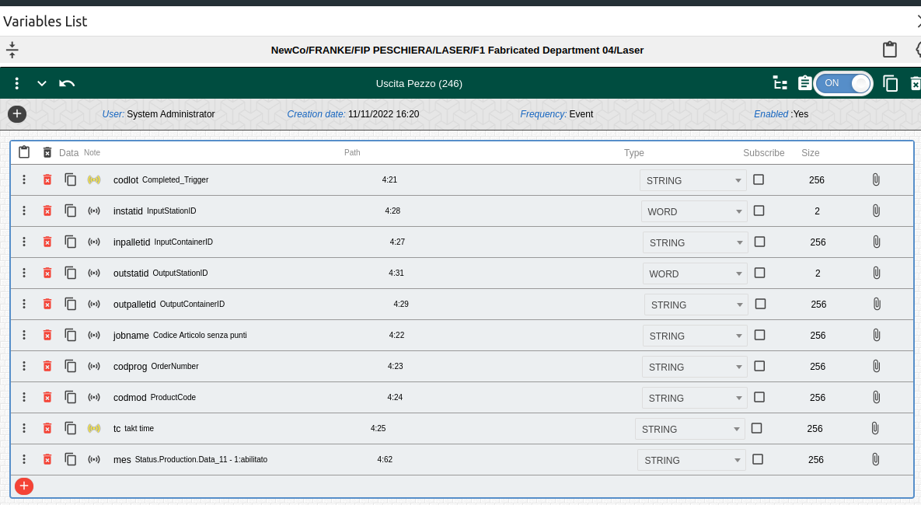

Piegatura

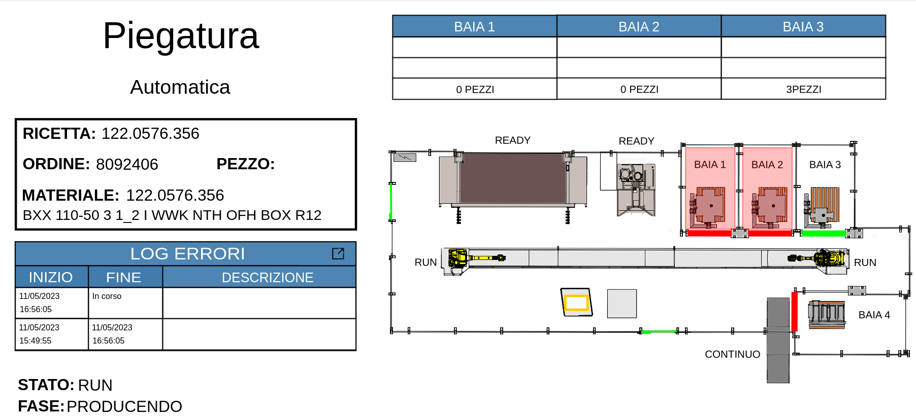

From the cut line, formats are positioned in pallet with a unique QR Code. The operator will be in charge to scan the QR Code of the pallet in output every time the pallet is changed.
Next is matching the material code of the format to the QR code of the pallet.

The operator has to associate to the pallet the finished product too.

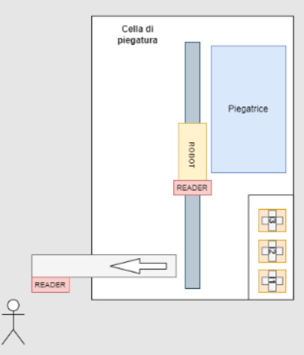

Input

x 3 times, 3 load stations

Output

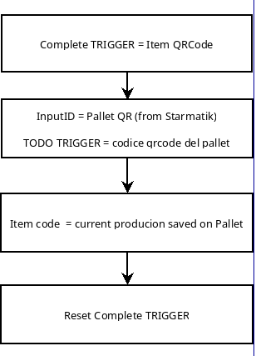

Data

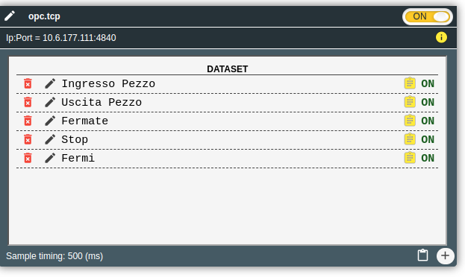

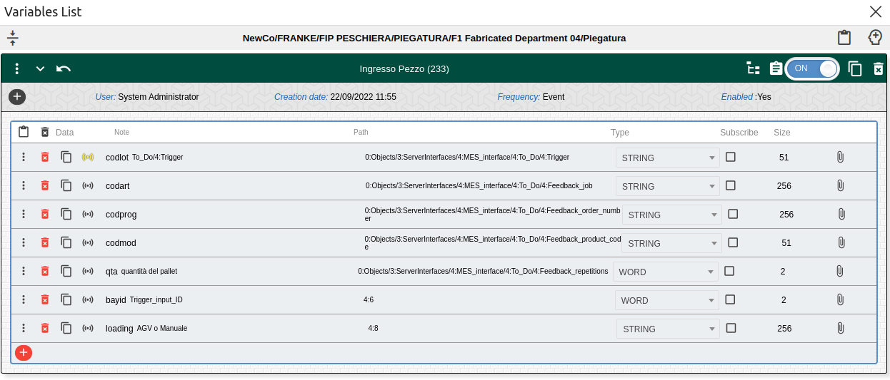

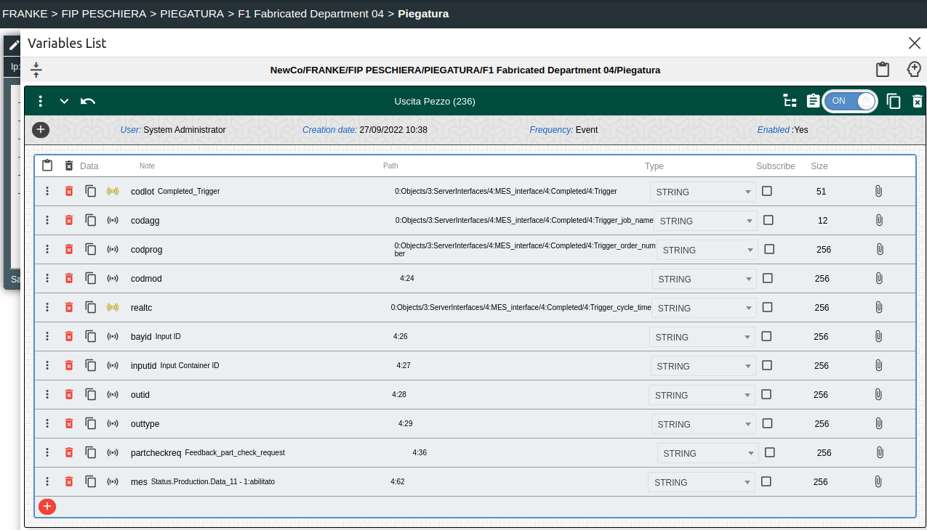

Saldatura

The first part of a new production is read through a qr reader by the improve touch and improve sends the information for the new order to the opc server.
with each piece that leaves the machine, Improve receives the corresponding qrcode.

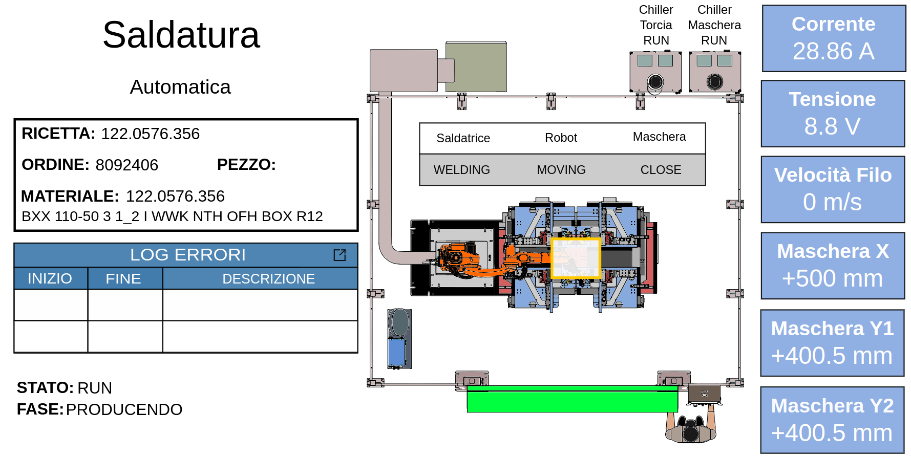
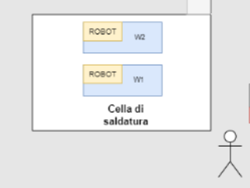

Input
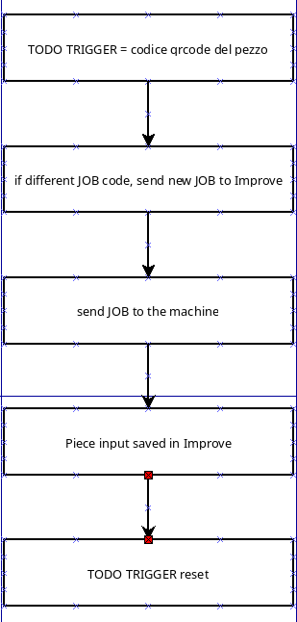

Output

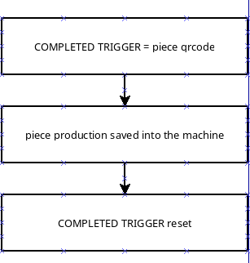

Data
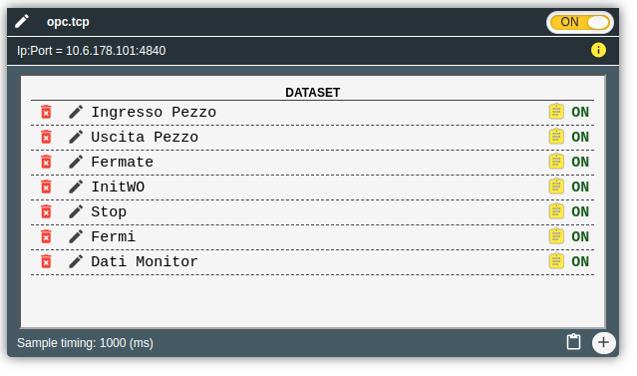

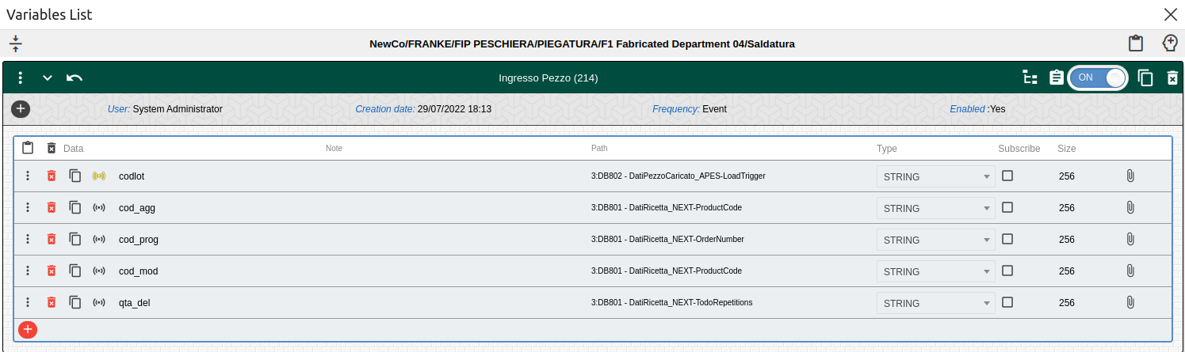

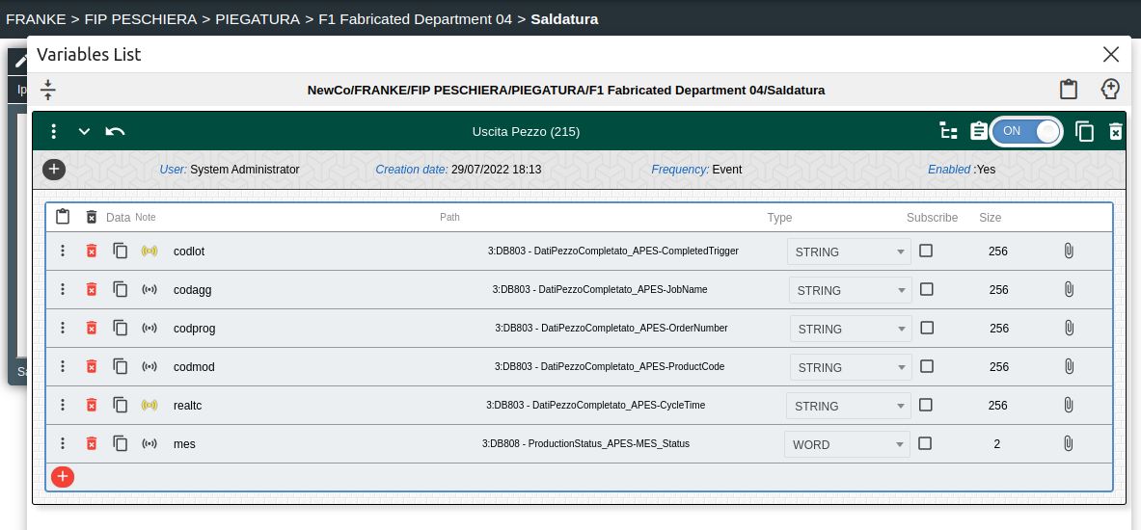

Personalizzazione

when a part goes through the conveyor comes to Next the qrcode.
If it is a qrcode that came out of the bender it has the production order with it and Improve analyzes whether the order saved in the machine is different.
Otherwise at each part we send to the opc server the order in Next

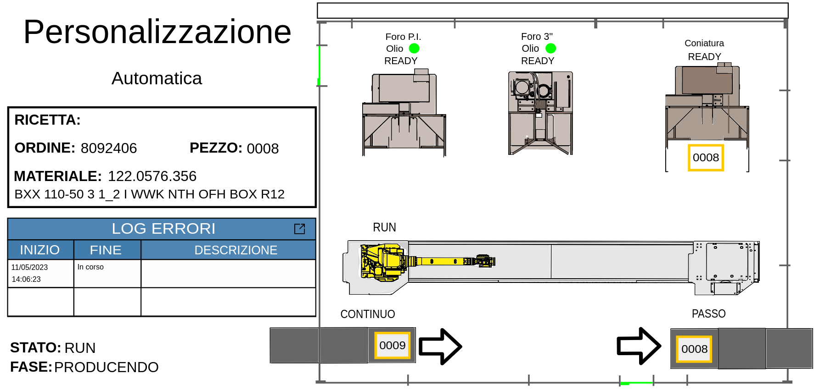
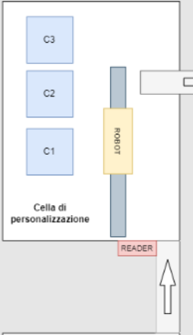

Input

Output

Data

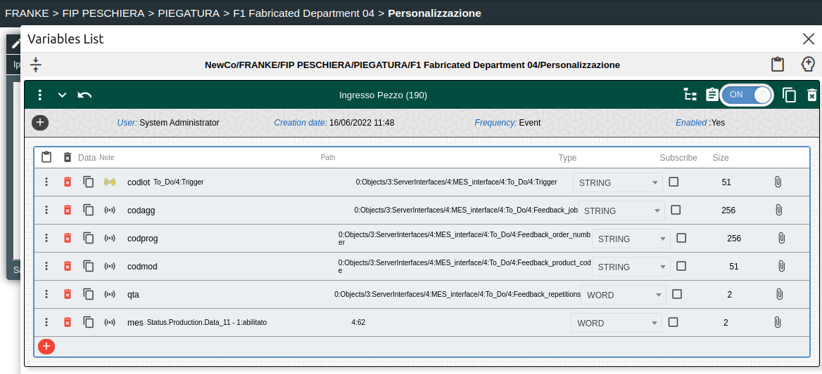

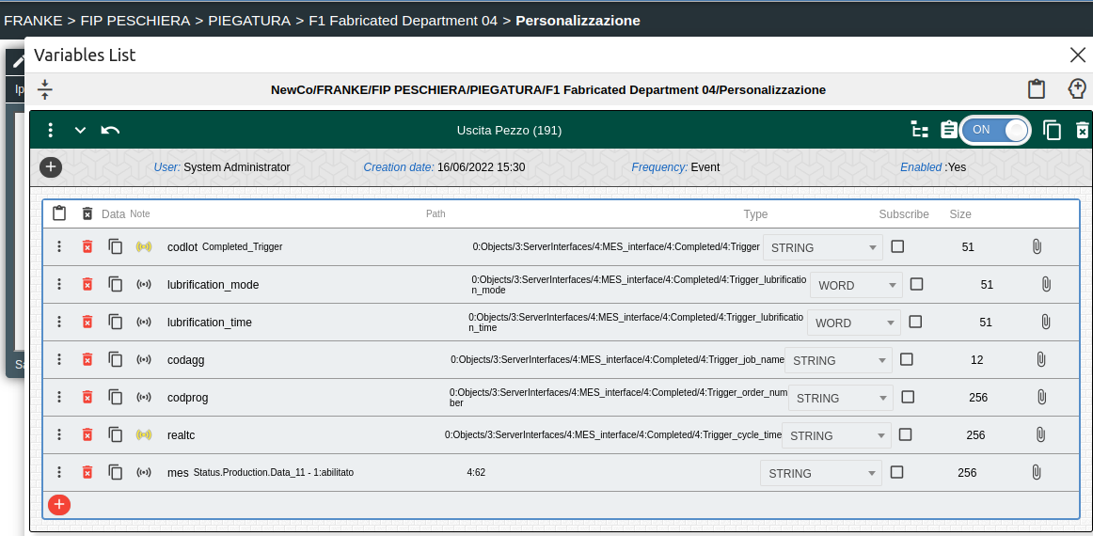

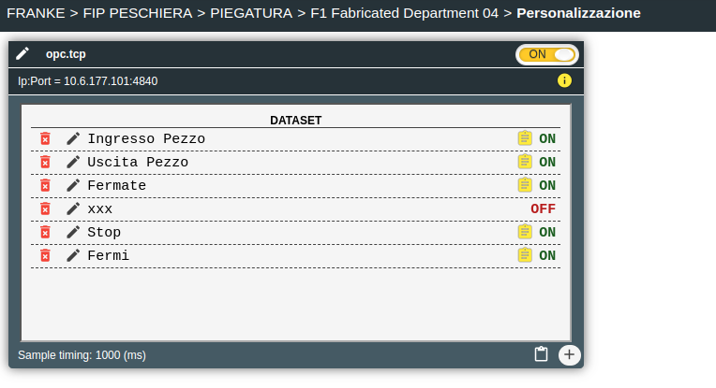

New item

Handle the production of each item.
Logic is event driven, OPC trigger

Schema is valid for Laser, Piegatura, Saldatura, Personalizzazione

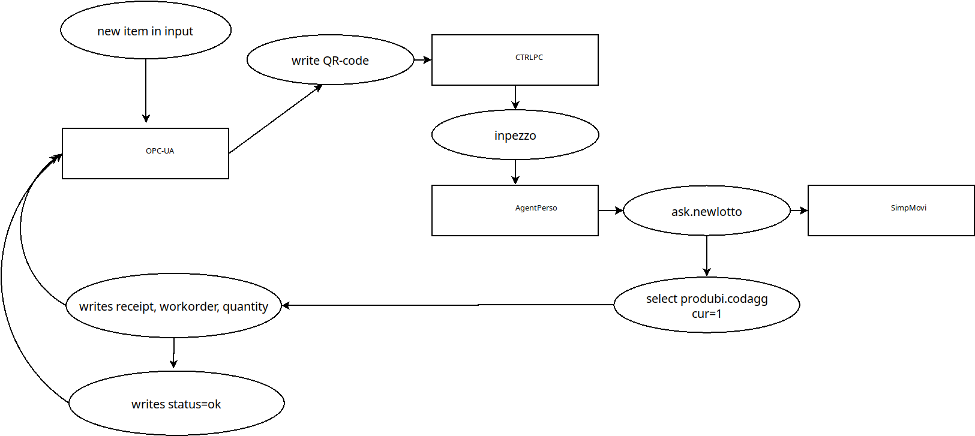

Traceability

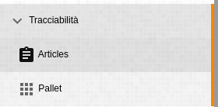

Articles
Logged informations :
S/N QR-Code
reading date and time
sending date and time
article code
SAP note or error message (if any)
warehouse location

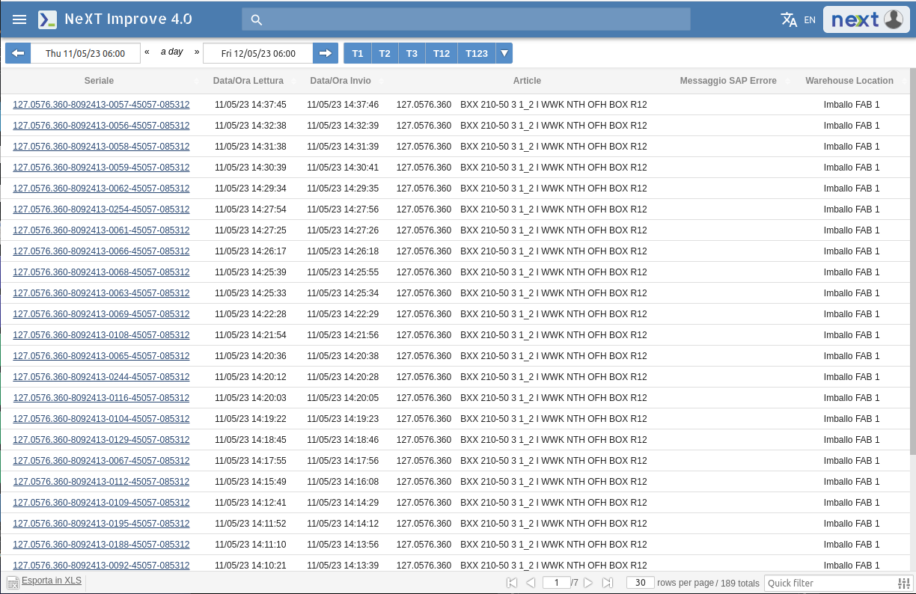

Pallet
Logged informations :

pallet code
location
quantity
article code
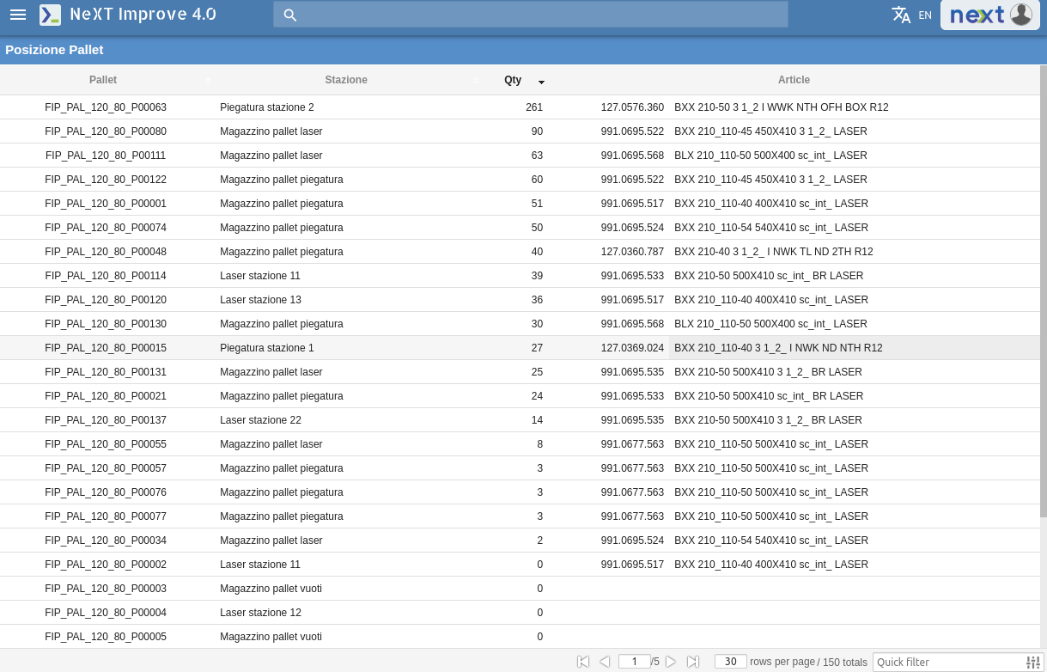

AGV - API Rest Server SAP -> NIS
The goal of this API is to provide information to NIS (Next IMPROVE System) about the work order related to the product units stocked on each of the entry position of a generic machine (in this case laser and bending machines).

Thanks to the communication between SAP and the AGV system, SAP knows exactly the time and the entry position where each product unit is stocked by the AGV (frequency diagram below).

Once SAP receives the message that defines the right completition of the AGV mission (stocking of a specific product unit in a specific entry location of a specific machine) it can send to NIS the related rueck.

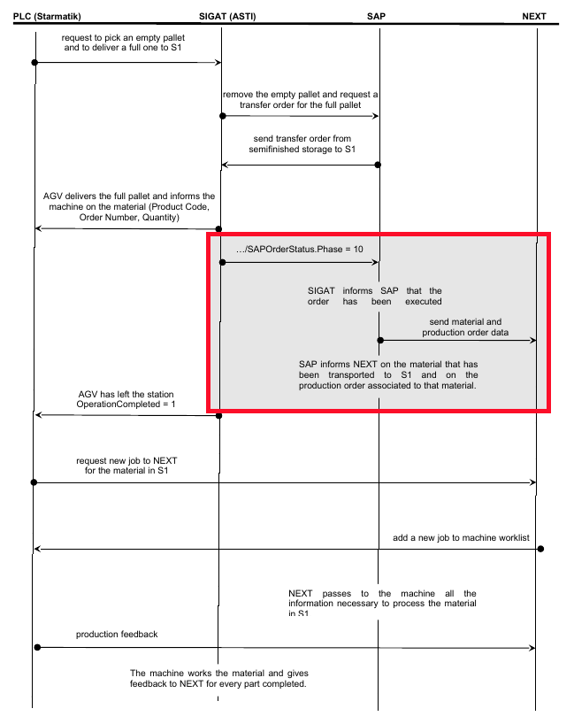

SAP will send to NIS the following information:
- machine entry position identifier: this is a shared identifier that is unique inside all the machines entry positions
- rueck: is the rueck related to the product unit stocket in the specific machine entry position
After that, NIS will download all the required information using the existing web service protocol. The following use case diagram describes the scenario.

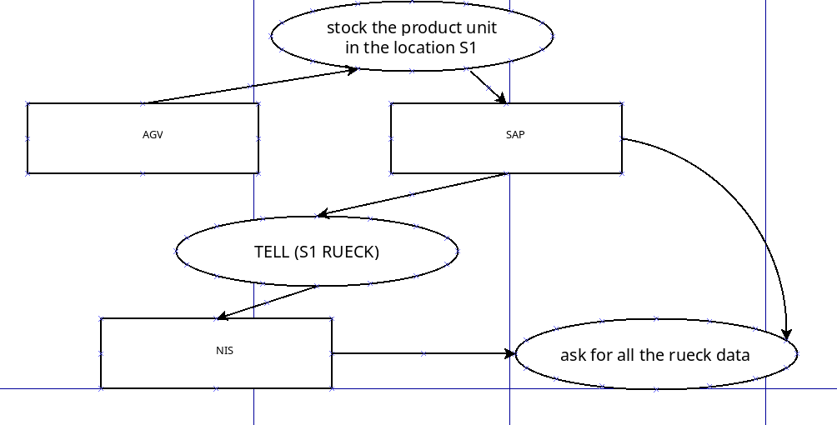

NIS will provide a REST server API with the following properties:
- IP:PORT ⇒ 255.255.255.255:9999 (to be defined, 10.100.145.19:5599 on the test server)
- Protocol HTTP with method POST
http://255.255.255.255:98999/iaf/tell/rueckmng
(http://10.100.145.19:5599/iaf/tell/rueckmng on the test server)
- BODY as json text:
{"request":"pustock","p1":{"werks":"xxx","entrypos":"XXXXXXX","rueck":"99999999","qty":"100"}}
In the following there is the description of the json fields
- request: is a static string value containing “pustock”
- p1: is the data object, where
  - entrypos: is the unique identifier of the machine entry position
  - rueck: is the related rueck
  - werks: plant code in SAP
  - qty: number of items in the pallet (pallet quantity)
The Rest server will answer through the following json object:
- {“rv”:“1”} if the operation is done with success
- {“rv”:“0”} if the operation is done without success
In the following there is an example using the curl command on the test server:
curl --request POST 'http://10.100.145.19:5599/iaf/tell/rueckmng' --header 'Content-Type: application/json' --data-raw '{"request":"pustock","p1":{"werks":"xxx","entrypos":"XXXXXXX","rueck":"99999999"}}'

Improve 4.0 Mobile

The Improve4.0 web application handle the Pallets locations and movements.

Material status visualization, Pallet material visualization, pallet material modification are the operation we can do throught the mobile application.

This application is configured to handle the 2 departments : Laser and Piegatura.

Through this few and simple screens the operators read pallet code, they can set production order and change the production quantity.

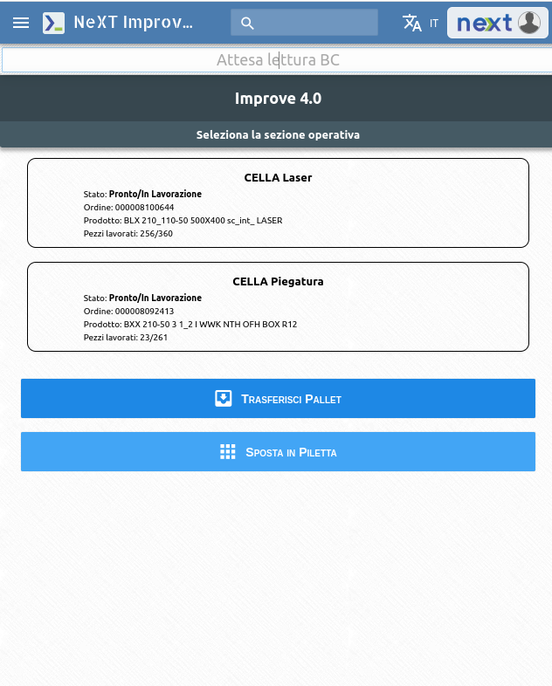

Yellow and blinking box is the pallet waiting to be Loaded\Unloaded
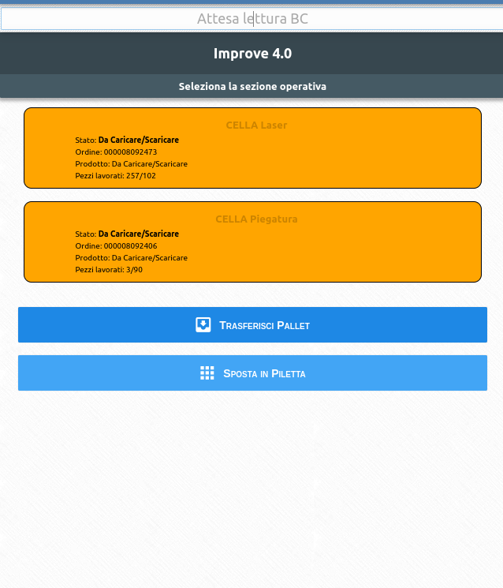

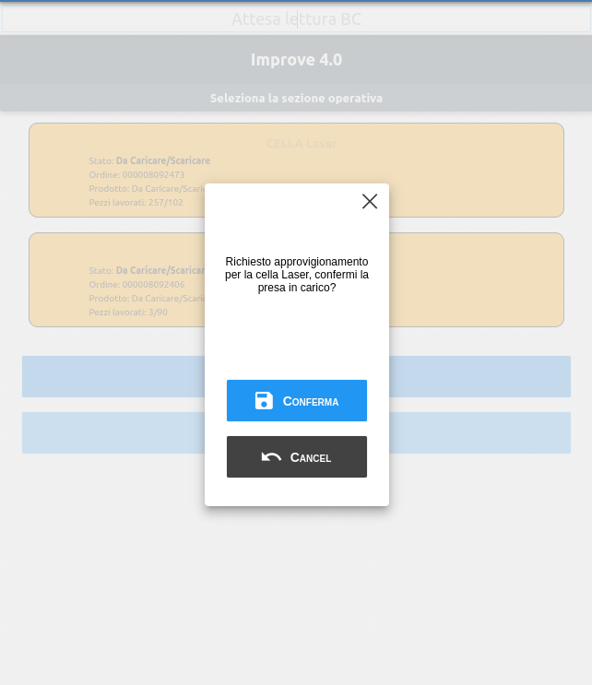
the operator can confirm other colleges related to the application that is bringing material to the machine

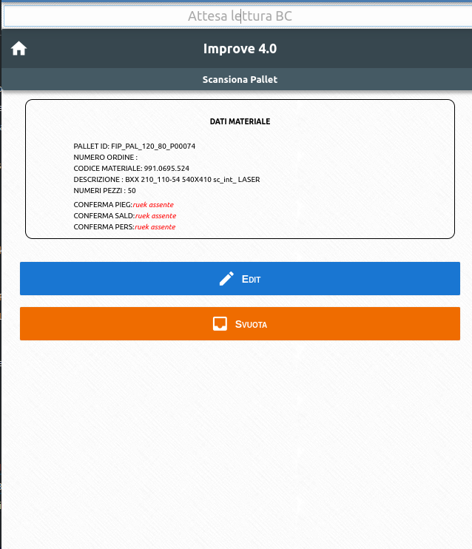
ruek assente means the order for that pallet has not been ready

The operator select the pallet throught the Barcode reader; ‘attesa lettura BC’ field can also be populated manually

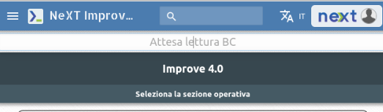

Once the pallet has been selected, it can be transferred
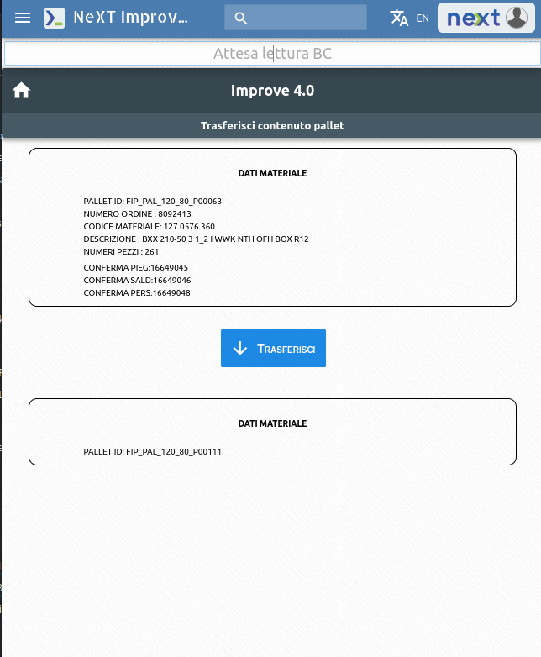

Transferring material from pallet to pallet
