Carousel Sample

Multiple productions active

It's possible to configure the system to manage the production of more than one work order in the same time. When the system detect the end cycle signal from the PLC, NIS will record the production of the specified article/articles, each with his quantity as following.

Production configuration with number of items produced for each work cycle

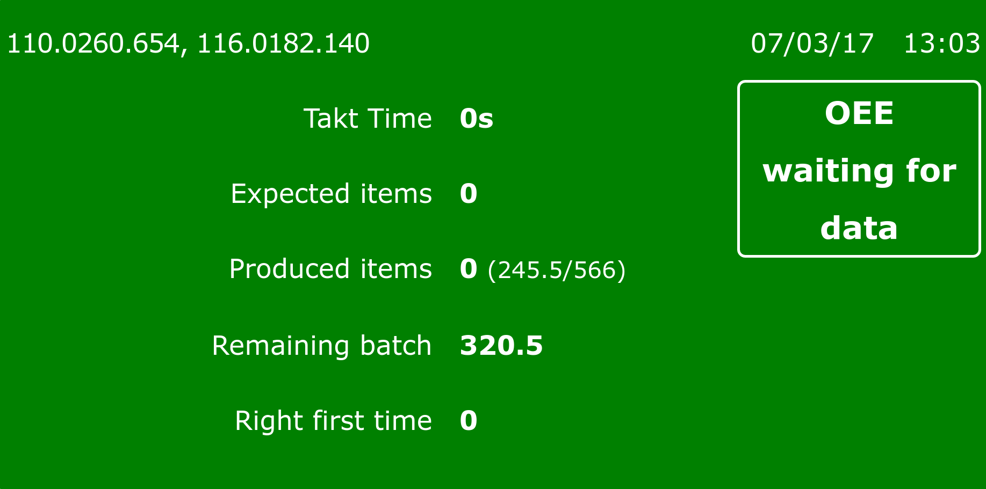

Scrap items with quantity and cause based on production
In case of multiple production at the same time, it's necessary to specify quantity and cause for each article.

