ERP Flashing back
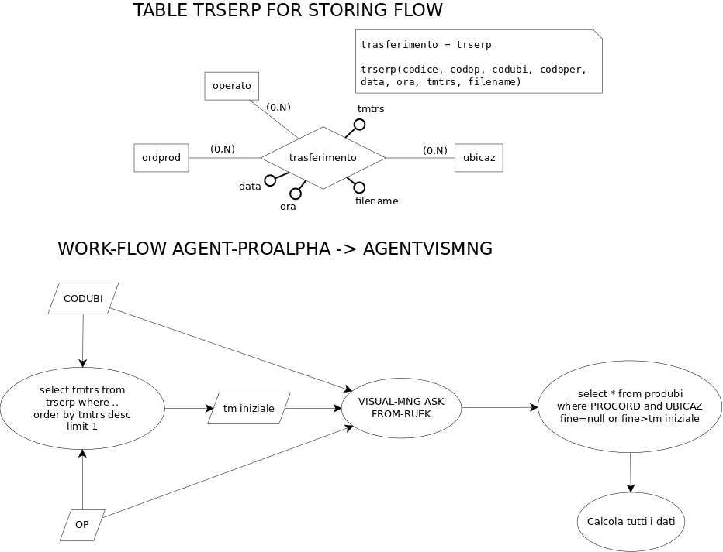
CREATE TABLE trserp (
codice INTEGER NOT NULL,
codop CHARACTER VARYING(51),
codubi CHARACTER VARYING(51),
codoper CHARACTER VARYING(51),
datatrs CHARACTER VARYING(9),
oratrs CHARACTER VARYING(9),
tmtrs INTEGER,
filename CHARACTER VARYING(101)
);
COMMENT ON COLUMN trserp.datatrs IS 'Data di trasferimento';
COMMENT ON COLUMN trserp.oratrs IS 'Ora di trasferimento';
COMMENT ON COLUMN trserp.tmtrs IS 'Tm di trasferimento';
COMMENT ON COLUMN trserp.filename IS 'Nome del file generato';
ALTER TABLE ONLY trserp
ADD CONSTRAINT trserp_pkey PRIMARY KEY (codice);

ProAlpha
<?xml version="1.0"?>
<dsOEE xmlns:xsi="http://www.w3.org/2001/XMLSchema-instance">
<Activity>
<Company>000</Company>
<WorkOrderNumber>1220433</WorkOrderNumber>
<IDAct>1683438</IDAct>
<ActPos>50</ActPos>
<Qty>444</Qty>
<QtyScrap>1</QtyScrap>
<ScrapRemark>Ausschuss</ScrapRemark>
<Resource>821102</Resource>
<Finished>no</Finished>
<TimeTE>43294</TimeTE>
<TimeTR>3514</TimeTR>
<TimeUnit>0</TimeUnit>
</Activity>
</dsOEE>
Il dato relativo ad ActPos va ricavato dal file di Input vedi sotto:
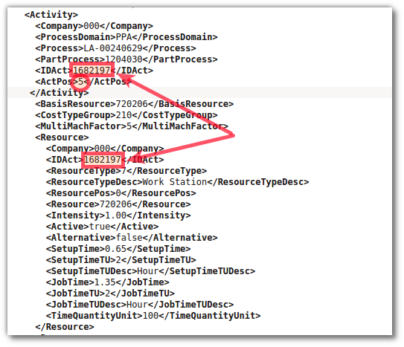
Dal file di Input bisogna alimentare la relazione "activity" dichiarata sotto
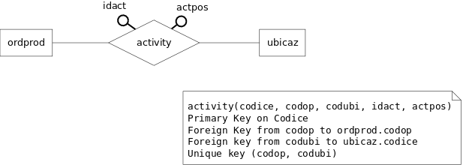
CREATE TABLE activity (
codice INTEGER NOT NULL,
codop CHARACTER VARYING(51),
codubi CHARACTER VARYING(51),
idact CHARACTER VARYING(51),
actpos CHARACTER VARYING(51)
);
COMMENT ON COLUMN activity.codop IS 'Codice ordine di produzione (ordprod.codop)';
COMMENT ON COLUMN activity.codubi IS 'Codice ubicazione (ubicaz.codice)';
ALTER TABLE ONLY activity
ADD CONSTRAINT activity_codop_codubi_key UNIQUE (codop, codubi);
ALTER TABLE ONLY activity
ADD CONSTRAINT activity_pkey PRIMARY KEY (codice);
ALTER TABLE ONLY activity
ADD CONSTRAINT activity_codop_fkey FOREIGN KEY (codop) REFERENCES ordprod(codop) ON DELETE CASCADE;
ALTER TABLE ONLY activity
ADD CONSTRAINT activity_codubi_fkey FOREIGN KEY (codubi) REFERENCES ubicaz(codice) ON DELETE CASCADE;

Query per visualizzare tali dati
Aktivität (Workorder Position/machine):
SELECT identif FROM ubicaz WHERE codice='821102A';
Menge Gut (number of good parts):
SELECT SUM(movimag.qta) AS npp FROM movimag INNER JOIN (lottim INNER JOIN (prodord INNER JOIN produbi ON prodord.codprod=produbi.codice) ON prodord.codop=lottim.procord) ON movimag.codlot=lottim.codice WHERE produbi.codubi='821102A' AND prodord.codop='1220433' AND (produbi.tmfi>'1493902281'OR produbi.tmfi IS NULL) AND movimag.codcau='PREL' AND movimag.codubi='821102A';
Menge Ausschuss (number of scrap):
SELECT SUM(movimag.qta) AS nps FROM movimag INNER JOIN (lottim INNER JOIN (prodord INNER JOIN produbi ON prodord.codprod=produbi.codice) ON prodord.codop=lottim.procord) ON movimag.codlot=lottim.codice WHERE produbi.codubi='821102A' AND prodord.codop='1220433' AND (produbi.tmfi>'1493902281'OR produbi.tmfi IS NULL) AND movimag.codcau='SCAPR' AND movimag.codubi='821102A';
Buchungshinweis (additional information about scrap):
SELECT causanc.codice, movimag.qta FROM causanc INNER JOIN (movimag INNER JOIN (lottim INNER JOIN (prodord INNER JOIN produbi ON prodord.codprod=produbi.codice) ON prodord.codop=lottim.procord) ON movimag.codlot=lottim.codice) ON causanc.codice=movimag.caudef WHERE produbi.codubi='821102A' AND prodord.codop='1220433' AND (produbi.tmfi>'1493902281'OR produbi.tmfi IS NULL) AND movimag.codcau='SCAPR' AND movimag.codubi='821102A';
Abgeschlossen (AkvP fertig) (status of work order partly oder finished):
SELECT SUM(movimag.qta) AS STATUS FROM movimag INNER JOIN lottim ON movimag.codlot=lottim.codice WHERE movimag.codcau='PREL' AND lottim.procord='1220433';
Mitarbeiter Nr. (ident. nr. of worker):
SELECT (CASE WHEN ndip IS NULL THEN '1' ELSE ndip END) AS nrworkers FROM ordprod WHERE codop='1220433';
Zeit te (working time machine/100st) ???:
SELECT SUM(tmdiff) FROM movimag WHERE codcau='INFM' AND tm>'1493902281' AND tm<'1493976666' AND codubi='821102A';
Zeit tr (setup time) ???:
SELECT SUM(tmdiff) FROM movimag WHERE codcau='FIFM' AND caufm='setup' AND tm>'1493902281' AND tm<'1493976666' AND codubi='821102A';

SAP flashing-back
The RFC function module name is /FOX/PP_ANDON_CONF
- Parameters:
  - budate = posting date
  - store = default 0
  - EXNAM = defautl space
  - iv_conftime is a structure - order number and yield quantity and unit of measure should be in, the times can be empty.
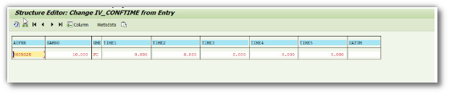
- iv_rueck contains the confirmation numbers.
The export parameter subrc = S - in case it worked or E it failed.
Here the different views on the FM you can call. all is on QE1 our test system need to be called via logon groups as for the other one before.
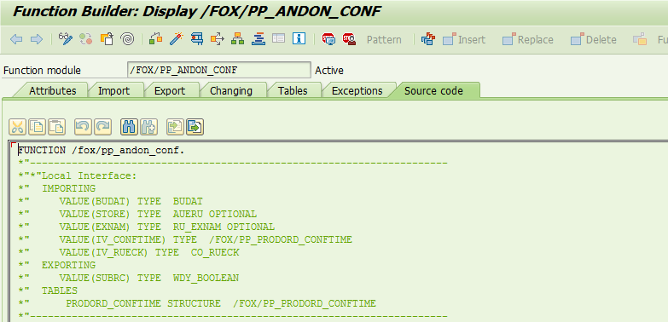
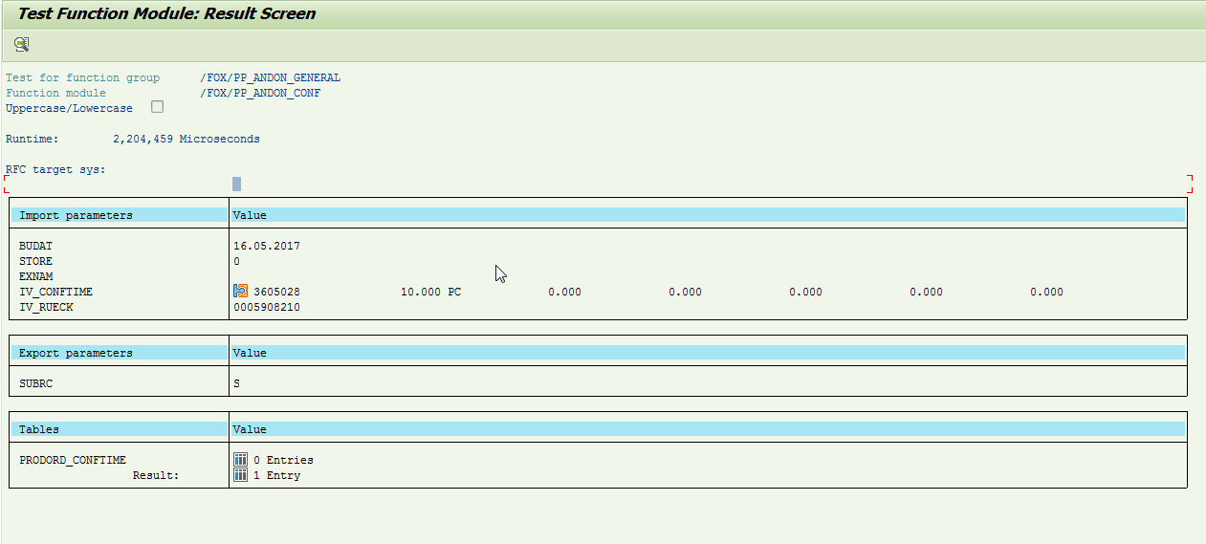

RFC /FOX/PP_ANDON_CONF: Data dictionary new version
Field name | Description
BUDAT | Data
AUFNR | Work order
IV_RUECK | Order confirmation
GAMNG | Number of produced items
GMEIN | Unit of measure (ST)
IV_FINAL | confirmed CNF state
IV_SCRAP | number of scrap items

