Failure causes management
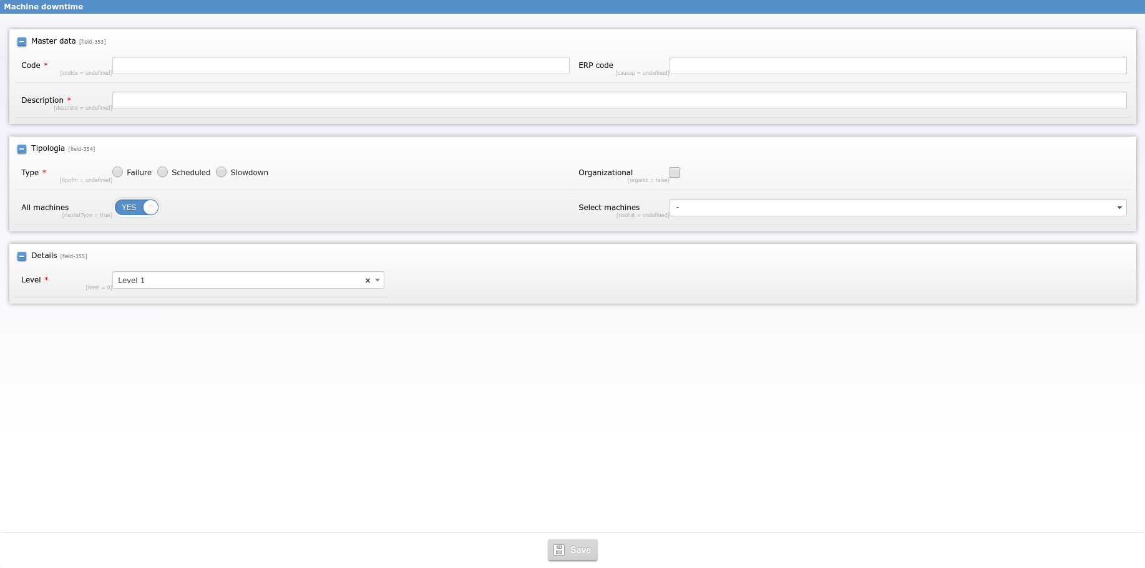
Using this interface it's possible to specify failure cause with 3 levels of depth, type of the slowdown (organizational or not), associated machine/machines.

