NIS - SURVEY
Subject: NeXT Improve System (NIS) Survey
Dear Mr Naegele,
Thank you for selecting NeXT Improve System. Compiling NIS Survey is the first step of our collaboration.
In the following you can reach some interesting and helpful links regarding NIS.
Google Drive for Global Agreement
https://drive.google.com/drive/u/1/folders/0B9dZYuE4NjvIRnBaRXpnZnpRRGs
NIS reportage:
- NIS in Berbentina - video tutorial
https://youtu.be/gyqT35s_ECc
- How to mount NIS devices - video tutorial
https://youtu.be/Msx0I2nggMs
We look forward to receiving your NIS Survey compiled. In any event, please do not hesitate to contact us should you require further information.
Kind Regards

E-Mail for requesting nis-go-deeper-format compiling
Dear Mr. AIO
my name is Lorenzo Bravi and i will manage sharing formats about first and second assessment for NIS in your plant, and i will support you for compiling them.
First i inform you about following video-reportage regarding PLCs and related electrical schema, please share it with your colleagues interested by the same:
- https://youtu.be/CSAA9SNxZQQ
Attached you can reach nis-go-deeper-format.xlsx.
You should compile it and then you should send me compiled file. Based on it and according to the "Global Agreement", i will prepare nis-shopping-list for your plant .
I attached also example-nis-go-deeper-format.xls in which you can find some helpful information for compiling (you can see also following picture).
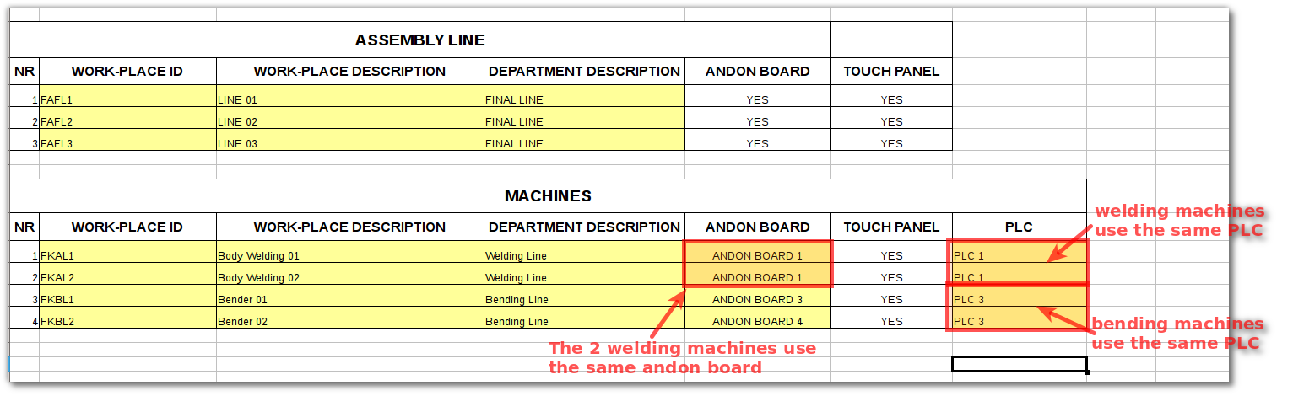
The principal aim of compiling this format is to understand the precise number of devices we should acquire for you.
The format is composed by 2 sections:
- ASSEMBLY LINES: it refers to information about assembly line
- MACHINES: it refers to information about machines
The data that you should compile are marked through yellow color.
In the first section (assembly lines) you should compile following information:
- work-place id: it refers to the identifier of the work-place; this identifier should be shared with the ERP (you can use ERP identifier of the work-place);
- work-place description: it refers to the description of the work-place
- department description: it refers to the description of the department in which the work-place is located
In the second section (machines), the first three columns are the same described above but in this case it's possible to share some devices, in particular:
- an "Andon Board" could be shared by more machines
- a PLC could be shared by more machines
Using cells under columns "Andon Board" and "PLC" you can define just that.
Naturally for sharing an Andon Board the machines that share it should be located in the same area (a little-area), so it's better to use only one Andon Board or it's really impossible to put more than one Andon Board (for space reason).
Furthermore a PLC could be connected at most to 4 machines (if you use 2 signal for each machine) at the same time; so we can optimize the number of PLC we will use; for sharing a PLC with more than one machine you should consider following:
- with a 1mm section cable you can reach a distance of at most 70m from the machine to the PLC
- the plant's technicians (internal or external) should provide for wiring and cables​
I hope you will haven't any difficulty to compile this format, othewise you could ask me any questions.
Kind Regards MyName

Attachment
- nis-go-deeper-format.xls
- example-nis-go-deeper-format.xls

Invio NIS Shopping List
Dear Mr. Cacciamurt
As requested, I attach NIS shopping list.
You can use attached shopping list for emitting purchase order.
If you have any questions, don't hesitate to call me.
Best Regards Myname

Attachment
File Pdf Shopping List.

Richiesta MAC-ADDRESS PLC

Attachment

Requesting IP-ADDRESSING

Attachment

