Visual Management and touch panels view - through Agents
AgentVisual is an AgentBase that implements an ask for answering "Visual Management" requirements.

Shift Definition
We should define before the "Shift definition" tables. Following tables schema
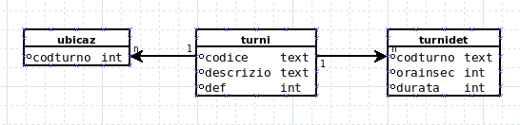
For identifying the shift we should use the tables TURNI and TURNIDEF. Each production line / machine should be mapped to shift code; table TURNIDEF defines details of each shift.
Following an example of table TURNI
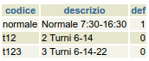
Following an example of table TURNIDEF
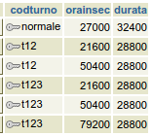
- TURNI.DEF=1 identifies the code of shift automatically assigned to each line that is not mapped explicitily to a shift;
- TURNIDET.ORAINSEC is the number of seconds from mind-night from which the shift begins
- TURNIDET.DURATA is the duration in seconds of the shift

Ask
Following a general schema for data required by a single line:
Field Name | Field Description
codart | Product code
descrizio | Product description
codop | Work order
tm | Takt Time
npp | Number of pieces expected from the begin of the shift or from the begin of WO
np | Number of pieces produced from the begin of the shift or from the begin of WO
npt | Total of pieces produced for work-order
s | Number of scrapt items in the shift
oee | OEE in the shift
rf | RF, RV, RQ in the shift
rv | RF, RV, RQ in the shift
rq | RF, RV, RQ in the shift
state | State of line/machine (1=running/0=stop)
causafm | Cause of current stop
caudesc | Description of current stop
tmfm | TM of beginning stop
tpfm | Class of current stop machine F=generic stop,S=Setup,O=Organizational,P=Pause
npwo | Number of items required from WO

Data required from Visual TV
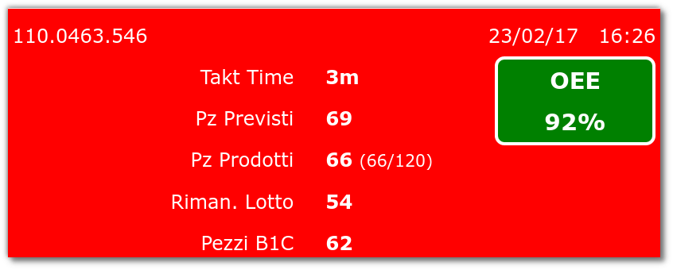
The following data refers to a specific production line / machine
Field Name | Field Description
codart | Product code
descrizio | Product description
codop | Work order
tm | Takt Time
npp | Number of pieces expected from the begin of the shift or from the begin of WO
np | Number of pieces produced from the begin of the shift or from the begin of WO
npt | Total of pieces produced for work-order
s | Number of scrapt items in the shift
oee | OEE in the shift
rf | RF, RV, RQ in the shift
rv | RF, RV, RQ in the shift
rq | RF, RV, RQ in the shift
state | State of line/machine (1=running/0=stop)
causafm | Cause of current stop
caudesc | Description of current stop
tmfm | TM of beginning stop
tpfm | Class of current stop machine F=generic stop,S=Setup,O=Organizational,P=Pause
npwo | Number of items required from WO

Data required from Visual Touch Panel
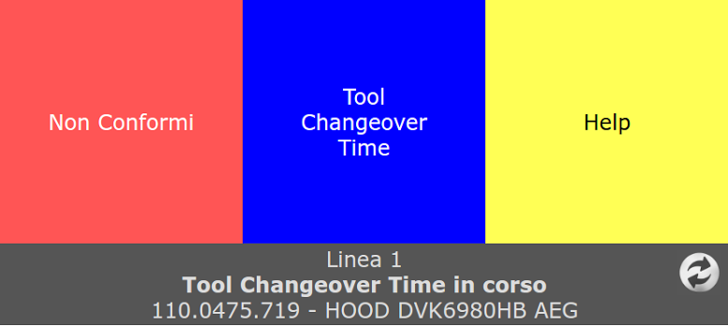
The following data refers to a specific production line / machine
Field Name | Field Description
codart | Product code
descrizio | Product description
codop | Work order
state | State of line/machine (1=running/0=stop)
causafm | Cause of current stop
caudesc | Description of current stop
tpfm | Class of current stop machine F=generic stop,S=Setup,O=Organizational,P=Pause
tmfm | TM of beginning stop

Data required from Visual Multi-Line
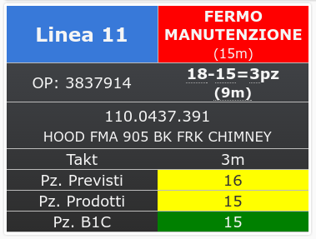
In this case we should have a row for each production line
Field Name | Field Description
codart | Product code
descrizio | Product description
codop | Work order
tm | Takt Time
npp | Number of pieces expected from the begin of the shift or from the begin of WO
np | Number of pieces produced from the begin of the shift or from the begin of WO
npt | Total of pieces produced for work-order
s | Number of scrapt items in the shift
oee | OEE in the shift
rf | RF, RV, RQ in the shift
rv | RF, RV, RQ in the shift
rq | RF, RV, RQ in the shift
state | State of line/machine (1=running/0=stop)
causafm | Cause of current stop
caudesc | Description of current stop
tmfm | TM of beginning stop
tpfm | Class of current stop machine F=generic stop,S=Setup,O=Organizational,P=Pause
npwo | Number of items required from WO

Other requirements
- Each production order should be changed and reworked in different time but in the same shift
- How we will manage multi-WO production ? We could use a JSON field containing information about WO ({wo:'xxx',codart:'yyy',descrizio:'kkk',npwo:'999'}

AgentVisualMng
AgentVisualMng has the aim to answer Visual Devices asks; it could have two type of asks:
- for giving information about a specific production line
- for giving information about a sub-set of production line (based on codubib)
- for giving information about all production line
In all cases the return value of the agent will be a IREC completed by all information required that are described in ask.
Request | andonrt
Data | Rec(codubi,codubib) | if codubi is not empty it queries a specific line, if codubib is not empty it queries specific department, if both are empty it queries all lines
Following IREC information returned by AgentVisualMng for each request
Field Name | Field Description
produbi | JSON: [{codop:'XXX',codart:'XXX',descrizio:'XXX',npwo:'999'},..]
tm | Takt Time
npp | Number of pieces expected from the begin of the shift or from the begin of PRODUBI
np | Number of pieces produced from the begin of the shift or from the begin of PRODUBI
npt | Total of pieces produced for PRODUBI
s | Number of scrapt items in the shift
oee | OEE in the shift
rf | RF, RV, RQ in the shift
rv | RF, RV, RQ in the shift
rq | RF, RV, RQ in the shift
state | State of line/machine (1=running/0=stop)
causafm | Cause of current stop
caudesc | Description of current stop
tmfm | TM of beginning stop
tpfm | Class of current stop machine F=generic stop,S=Setup,O=Organizational,P=Pause
npwo | Number of items required from PRODUBI

