Shared database

Database access technical data
Server IP | regional server IP
Port | 5432
Database type | PostgreSQL
Access mode | ODBC
ODBC Driver | 32bit, 64bit
Database Name | andon_PLANT_CODE
Username | frankerp
Password | f17!

E-R database schema
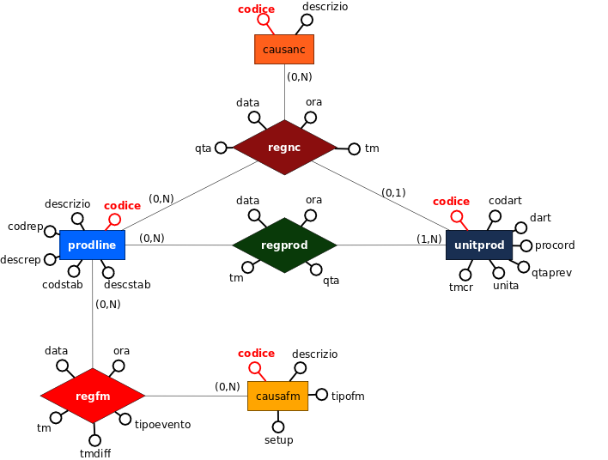

Data dictionary

Entities
Entity
Name | Description | Attributes
 |  | Name | Description | Type | Identifier
prodline | Production lines | key | Line unique key | varchar | SI
 |  | descrizio | Line description | varchar
 |  | codrep | Department code | varchar
 |  | descrep | Department name | varchar
 |  | codstab | Plant code | varchar
 |  | descstab | Plant description | varchar
unitprod | Unique production id, produces items | codice | Production unit unique code | varchar | YES
 |  | codart | Article code | varchar
 |  | dart | Article descrption | varchar
 |  | procord | Production Order (ERP) | varchar
 |  | qtaprev | Number of items to be produced per production order | double
 |  | unita | Number of pieces per unit production (usually 1) | double
 |  | tmcr | Production unit creation Epoch Time (number of seconds from Jan 1, 1970) | long
 |  | datacr | Creation date in YYYYMMDD format (database date) | varchar
 |  | oracr | Creatione time formatted as HH:MM:SS (HH=00..24) | varchar
causanc | Non-conformity causes list | codice | Cause unique code | varchar | SI
 |  | descrizio | Non-conformity cause description | varchar
causafm | Line stop causes list | codice | Stop cause unique code | varchar | SI
 |  | descrizio | Line stop cause description | varchar
 |  | tipofm | Type of stop: F = downtime, M = micro-stop, P = programmed pause | varchar
 |  | setup | Referred to tooling stops: 1 = stop is a tooling, 0 = stop is not a tooling | integer

Relations
Relations
Name | Description | Components | Attributes
 |  |  | Name | Description | Type
regprod | Each row represents a production event | prodline, unitprod | data | Event date formatted as YYYYMMDD | varchar
 |  |  | ora | Event time formatted as HH:MM:SS | varchar
 |  |  | tm | Event Epoch time (number of seconds elapsed from Jan 1, 1970) | long
 |  |  | qta | Number of produced pieces in production units | double
regnc | Each row represents a non-compliant event | prodline, unitprod, causanc | data | Event date formatted as YYYYMMDD | varchar
 |  |  | ora | Event type formatted as HH:MM:SS | varchar
 |  |  | tm | Event Time Epoch (number of seconds from Jan 1, 1970) | long
 |  |  | qta | Number of scrapt items (production units) | double
regfm | Every row represents a begin or end of a line stop | prodline, causafm | data | Event date formatted as YYYYMMDD | varchar
 |  |  | ora | Event type formatted as HH:MM:SS | varchar
 |  |  | tm | Event Time Epoch (number of seconds from Jan 1, 1970) | long
 |  |  | tmdiff | Time difference between 2 consecutive events, being them start or stop doesn't matter | long
 |  |  | tipoevento | INFM=line stop begins, FIFM=line stop ends | long

Logical Schema
Table | Foreign keys
prodline(codice, descrizio, codrep, descrep, codstab, descstab)
unitprod(codice, codart, dart, procord, qtaprev, unita, tmcr, datacr, oracr)
causanc(codice, descrizio)
causafm(codice, descrizio, tipofm, setup)
regprod(codice, data, ora, tm, qta, codlot, codubi) | - codlot foreign key on unitprod.codice  - codubi foreign key on prodline.codice
regnc(codice, data, ora, tm, qta, codlot, codubi, caudef) | - codlot foreign key on unitprod.codice  - codubi foreign key on prodline.codice  - caudef foreign key on causanc.codice
regfm(codice, data, ora, tm, tmdiff, tipoevento, codubi, caufm) | - codubi foreign key on prodline.codice  - caufm foreign key on causafm.codice

Example Queries
Produced pieces on Sep 18, 2017 with date, time, unique identifier, line description, department description, article description and production order, ordered by production time
SELECT DATA, ora, codlot, prodline.descrizio AS linea, prodline.descrep, unitprod.dart, unitprod.procord FROM regprod
INNER JOIN prodline ON prodline.codice=regprod.codubi
INNER JOIN unitprod ON unitprod.codice=regprod.codlot
WHERE DATA='20170918'
ORDER BY tm
Produced pieces after Sep 17 (included) grouped by day, product and production order on line 151301
SELECT DATA, unitprod.dart, unitprod.procord, SUM(qta) AS pezzi FROM regprod
INNER JOIN unitprod ON unitprod.codice=regprod.codlot
WHERE regprod.codubi='151301' AND regprod.data>='20170917'
GROUP BY DATA, dart, procord
List of line 151301 stop (begins and ends) from 06:00 to 14:00 of Sep 17, with date, time, run/stop time in minutes, type of stop, stop cause description, stop type, setup (1,0)
SELECT DATA, ora, tmdiff/60 AS dtm, tipoevento, causafm.descrizio AS dfermo, causafm.tipofm, causafm.setup FROM regfm
INNER JOIN causafm ON causafm.codice=regfm.caufm
WHERE codubi='151301' AND DATA='20170917' AND ora>='06:00' AND ora<='14:00'
ORDER BY tm

