Regional servers
VPN Franke:
- usr: Francesco.Pirani.ext@faberspa.com
- pwd: NextSoftware!

Aarburg (fkt20g)
Host Name | IP | credentials | other
 | 10.100.145.20
FKT90G | 10.100.145.90 | nextop P@%!wPTu4Nhf | Server DB
 | 10.100.145.91 | nextop l0uSIFL80ht@ | Server CPP
 | 10.100.145.92 | nextop ^o#uc^0TE&bM | Server WWW

Active Plants
Franke Code | Description | NeXT WebApp | Database | file delle richieste di modifiche | other
FKT (Shared XLS) | Aarburg Svizzera | franke/andon | andon
FWK | KWC Unterkulm Svizzera | fwk/andon | andon_FWK
FFT | Manisa Turchia | fft/andon | andon_FFT
FPL | Gdynia Polonia | fpl/andon | andon_FPL
FIP | Peschira del Garda | fip/andon | andon_FIP
FBS | Bad Saeckingen Germania | fbs/andon | andon_FBS
FFU | Byske Svezia | ffu/andon | andon_FFU
FNL | Helmond Olanda | fnl/andon | andon_FNL
FIPBIA | Peschira del Garda | fipbia/andon | andon_FIPBIA
FGD (Shared XLS) | Žilina Slovacchia | fgd/andon | andon_FGD
FHN | Naarajärvi Finlandia | fhn/andon | andon_FHN
FPW (Shared XLS) | Sekocin Nowy Polonia | fpw/andon | andon_FPW
FRU | Russia | fru/andon | andon_FRU

Ruston (fhp21g)
IP | credentials | other
10.60.1.21

Active Plants
Franke Code | Description | NeXT WebApp | Database | other
FHP | Ruston | fhp/andon | andon_FHP

Asia (FPX88G)
IP | credentials | other
10.164.1.88
10.164.1.90 | nextop w$bU#Q$E6ou# | Server DB
10.164.1.91 | nextop i$Z#V#oF0DS1 | Server CPP
10.164.1.92 | nextop %8nj(7&Ocm8W | Server WWW

Active Plants
Franke Code | Description | NeXT WebApp | Database | other
FNO (Shared XLS) | Ronggui, Shunde Cina | fno/andon | andon_FNO
FPK (Shared XLS) | Heshan City Cina | fpk/andon | andon_FPK
FIM | Aurangabad India | fim/andon | andon_FIM

South Africa (FSA36G)
IP | credentials | other
10.184.1.36
10.184.1.90 | nextop 9)qF!%4laMIc | Server DB
10.184.1.91 | nextop 2A0c$ntkjN#! | Server CPP
10.184.1.92 | nextop T6Dmc@DBlZ8% | Server WWW

America (FHU241G - FHU242G - FHU243G)
IP | credentials | other
10.60.1.241 | nextop P^ziy7C0zji( | Server DB
10.60.1.242 | nextop ^6258lN3b0rW | Server CPP
10.60.1.243 | nextop Iv6RqED0PU&K | Server WWW

Active Plants
Franke Code | Description | NeXT WebApp | Database | other
FSA (Shared XLS) | Durban Sud Africa | fsa/andon | andon_FSA

Sassoferrato
IP | credentials | other
10.205.1.76 (FFI76G)
10.205.1.82 (FFI82G) |  | OEE NexT Italy - PowerUser (sostituisce il vecchio FFI74G con ubuntu 10.04)

Active Plants
Franke Code | Description | NeXT WebApp | Database | other
FFO | Sassoferrato | franke/andon | andon_FFO

Application Architecture
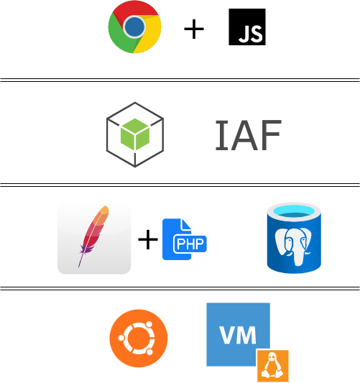

PULSE FRANKE
wget https://dl.technion.ac.il/docs/cis/public/ssl-vpn/ps-pulse-ubuntu-debian.deb
sudo apt-get install libcurl4 libnss3-tools
sudo dpkg -i ps-pulse-ubuntu-debian.deb
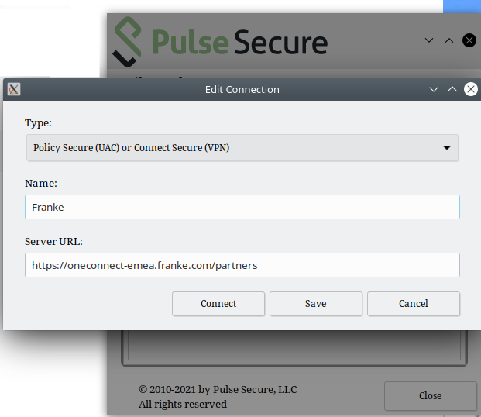
Server URL: https://oneconnect-emea.franke.com/partners
Gli User sono di Armando, Pirani e Strappini (quella di Strappini prenderela dal VMWARE)
La prima volta vuole l'SMS

