Training Topic
Definition: NIS: NeXT Improve System

General overview of NIS

Network
- Architecture
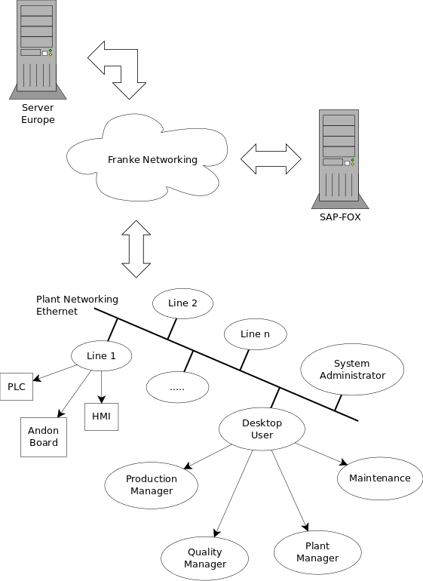

Server
- The aim of the server, the software architecture in server side
  - Database
  - Agents
  - Web-Server
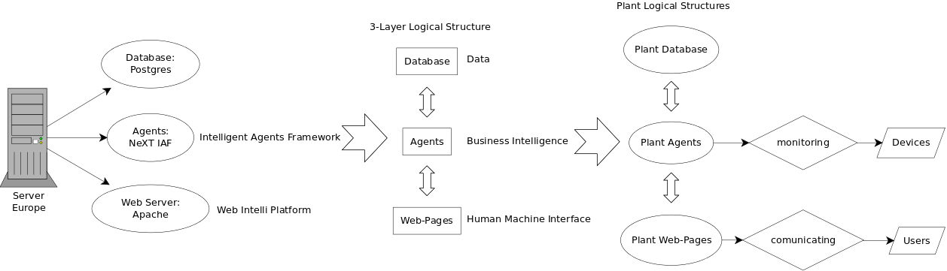

The Field

Touch panels
- Usage

Andon screens
- Architecture
- Data Meaning

Plc
- Kind, Architecture, Aim

Database

Administration
- Managing Users and Permissions

Required Tables - Settings
- Departments
- Machines / Lines
- Stop causes
- Not conformity causes
- Work-Order and Takt Time
- Shift Definition

Operative Data Source
- How does the structure look like (just short)

Data Warehouse
- How does the structure look like (just short)

OEE Calculation
- What are the formulas for RF, RV, RQ related to Franke data
- The time horizon
- The mid-night problem

Evaluation of acquired data

Graphical User Interface Eval / Modify
- Current State of Department
- Short time OEE views
- How can we find incorrect data / plausibility check e.g. target / actual comparison of production time per day, production order, material target / actual comparison of setup time per day, production order, material
- How can errors be corrected on a fast way
- How can unplaned breakes be found fast and be defined with the correct downtime reason

Reports
- Reports in general
- CIC Reports
- Cell Reports
- OEE Overview
- impact of shifts, just for layout or ?

Training Timing
Training executed in 2 sessions one per day:
- First Session
  - General Overview
  - Database
- Second Session
  - OEE Calculation
  - Evaluation of acquired data
  - Reports
Following schema describes timing


