NIS Work-Flow

Iteration 1: Purchase Order
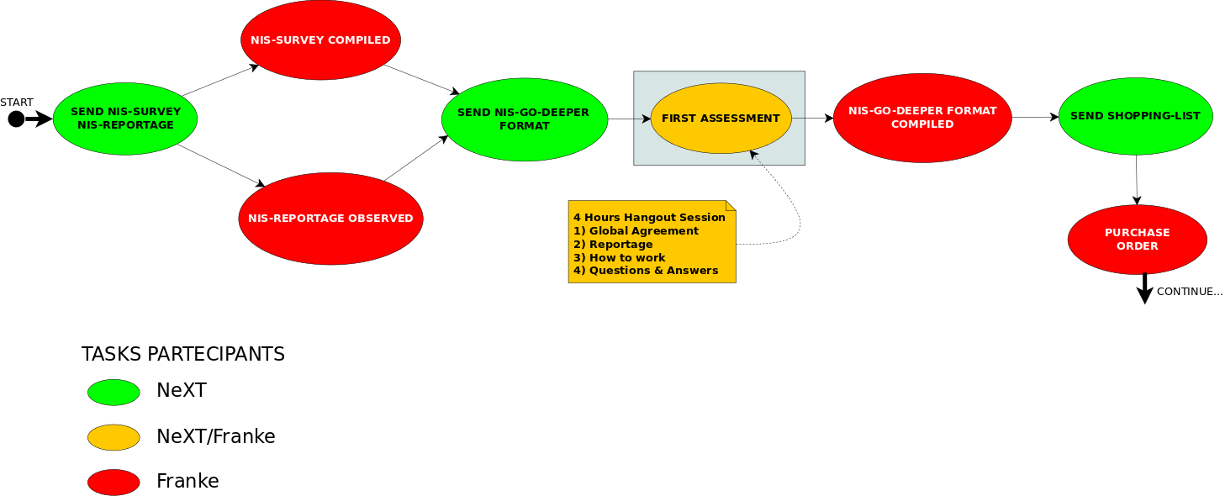

Iteration 2: First Line
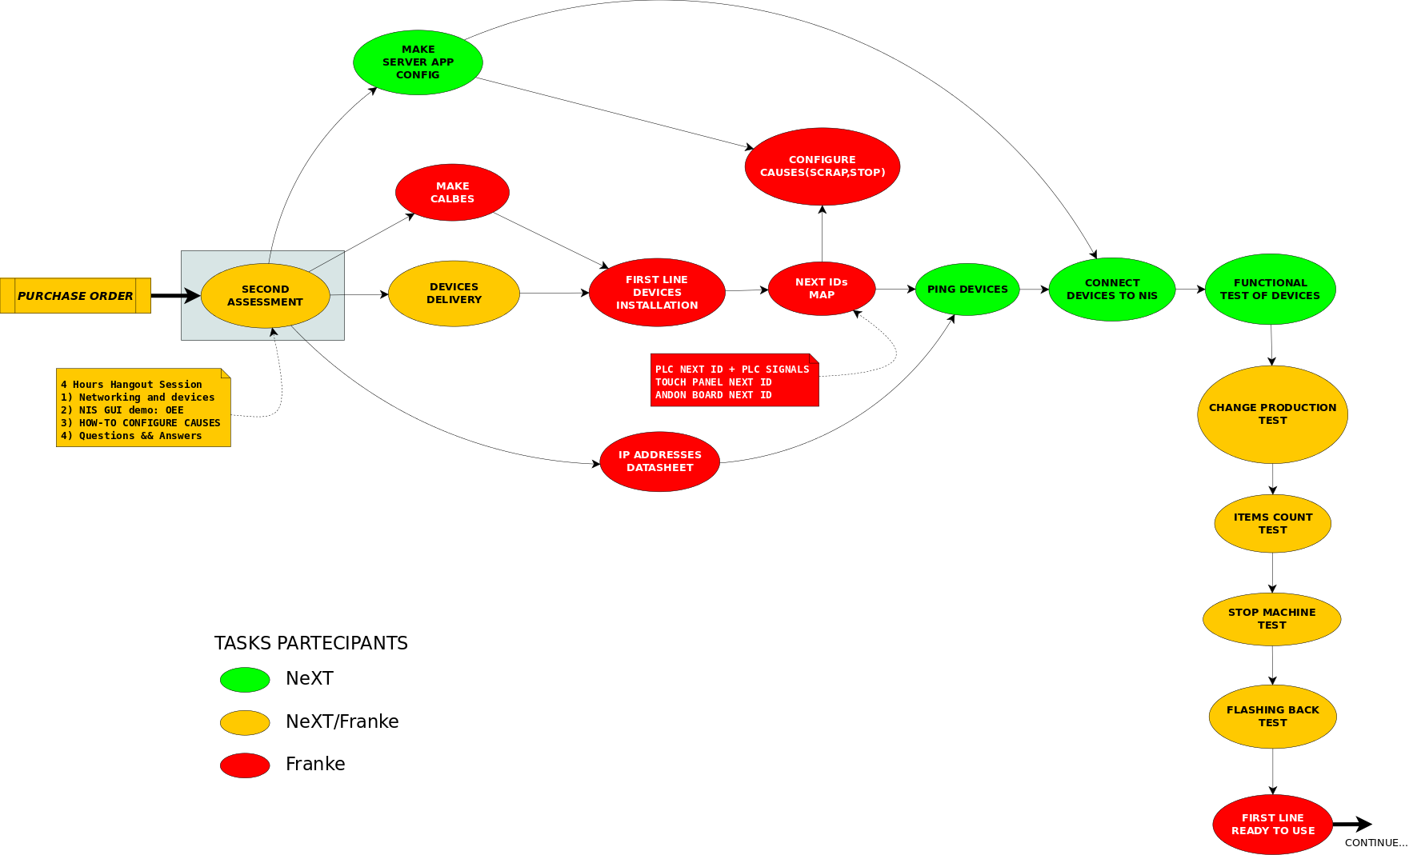

Iteration 3: Training, Go-Live
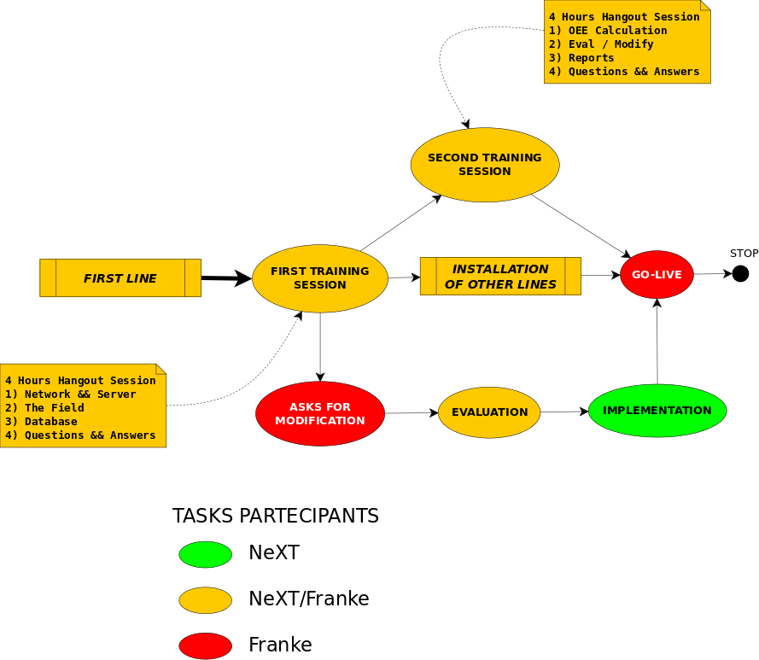

Iteration 4: Other Lines


